**Cloud Computing**

**Practical-7 Creating and running virtual machines on Bare-Metal Hypervisors Type 0**

**Name: Parth Sandip Sante**

**Roll no. A055**

**1)Bare-Metal Hypervisors**

A bare-metal hypervisor, also known as a Type 1 hypervisor, is virtualization software that runs directly on the host's hardware, without requiring an underlying operating system. This setup allows the hypervisor to have direct access to the hardware resources, resulting in improved performance, security, and efficiency. Bare-metal hypervisors are commonly used in data centers and enterprise environments where high-performance virtual machine (VM) hosting is essential.

**2) Bare-Metal Hypervisors Type 0**

Type 0 hypervisors are highly specialized, vendor-specific hypervisors built directly into the hardware (firmware or microcode) rather than as a separate software layer. Type 0 hypervisors are often found in large, specialized hardware systems where the hypervisor functions as a minimal layer that handles virtualization tasks, allowing for close integration with hardware resources. These hypervisors are generally more efficient but less flexible, as they are tailored for specific hardware use cases.

Examples: IBM PR/SM (Processor Resource/Systems Manager), Hitachi's Virtage.

**3) Bare-Metal Hypervisors Type 1**

Type 1 hypervisors, often simply called bare-metal hypervisors, are installed directly on the physical hardware. They control the hardware resources and allow multiple virtual machines to run independently on the host. Type 1 hypervisors offer high performance, reliability, and security, as they are optimized for managing virtualized environments in production.

**Examples**: VMware ESXi, Microsoft Hyper-V, Citrix XenServer.

**4)VMware**

VMware is a company specializing in cloud computing and virtualization technology, and it is best known for its Type 1 hypervisor, VMware ESXi. VMware’s suite of products includes both enterprise-level and desktop-level virtualization solutions. VMware ESXi is widely used in enterprise environments due to its reliability, performance, and rich feature set, including advanced management and automation tools.

VMware also offers VMware Workstation and VMware Fusion, which are desktop virtualization products (Type 2 hypervisors) that run on top of existing operating systems, such as Windows and macOS. These solutions are geared more towards individual users or developers rather than large-scale, production-grade virtualization.

**5)VirtualBox**

VirtualBox is an open-source Type 2 hypervisor developed by Oracle. It allows users to run multiple operating systems on a single machine by installing the hypervisor as an application on a host operating system. VirtualBox is popular among developers, testers, and students due to its flexibility, cross-platform support, and cost-effectiveness.

As a Type 2 hypervisor, VirtualBox runs on top of an existing operating system, which makes it easy to install and use but may have slightly lower performance and security compared to Type 1 hypervisors. However, it provides an accessible entry point for running virtual machines on personal computers for testing, learning, and development.

**Name: Heeta Parmar**

**Roll No: A049**

Virtualisation

MOBAXTERM

**Using Ubuntu Instance**

Create EC2 insatnce on AWS for Ubuntu

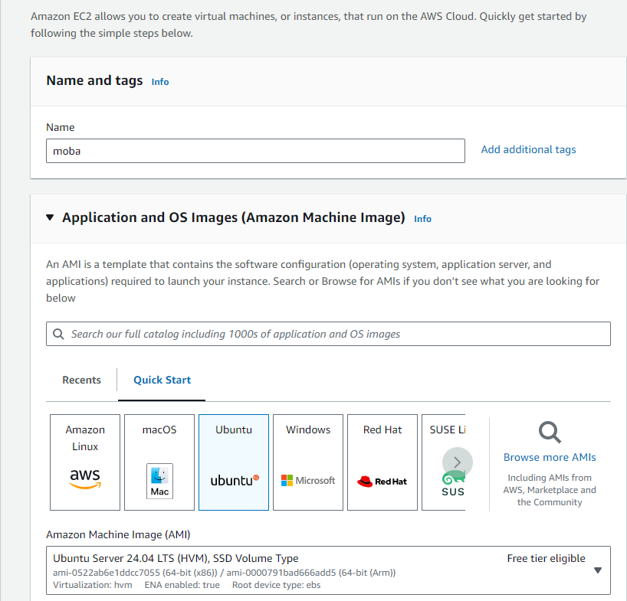

Create a new key pair and launch the instance.

Connect the instance once ready and copy the public IP address

Open MOBAXTERM and click on Session

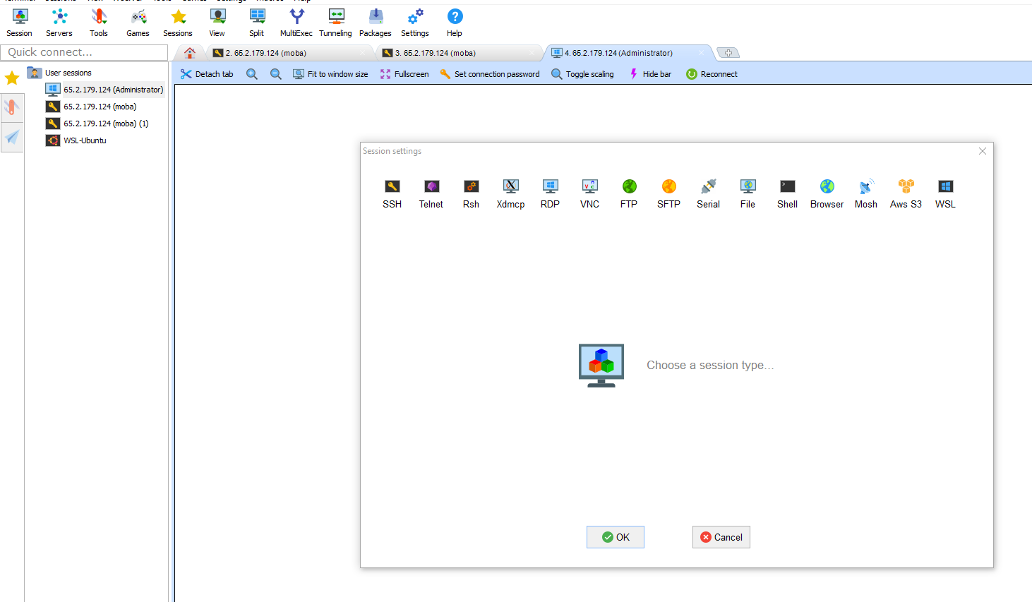

Select SSH and insert public IP address in remote host

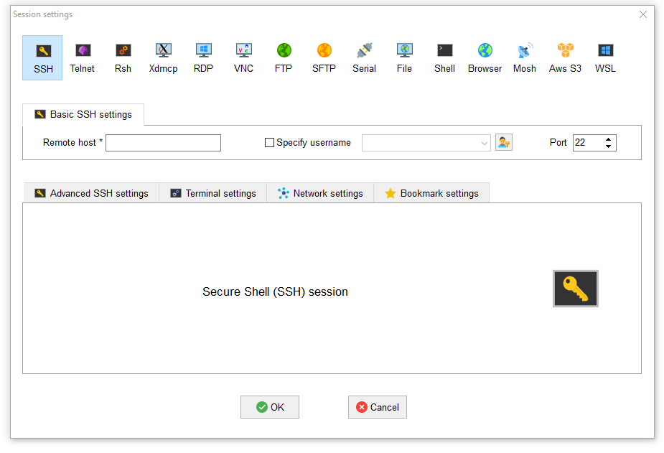

Choose specify username and insert instance’s name

Select Advanced SSH settings

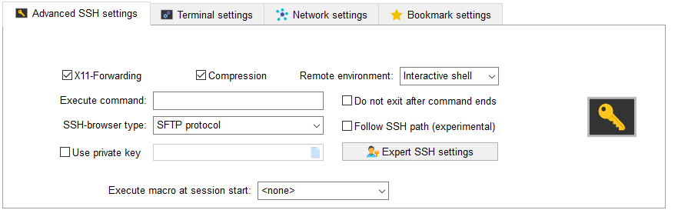

Select use private key and attach the new key pair file created and press okay

**Using Windows**

Create an EC2 instance with windows server

Create new key pair and launch the instance.

While connecting the instance open the RDP client section for Username and password

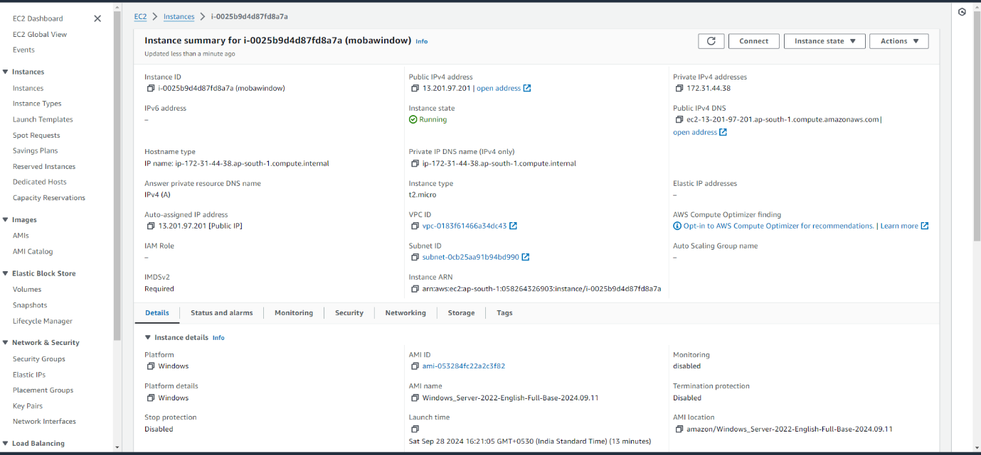

**Open mobaxterm and Select Sessions>RDP**

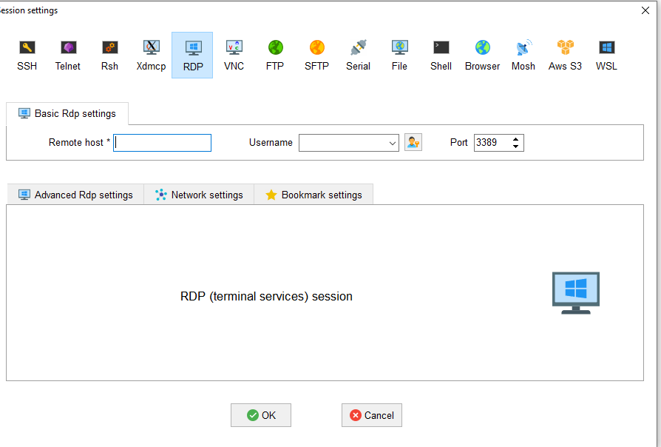

**Copy the Public IP address and username from Window instance :**

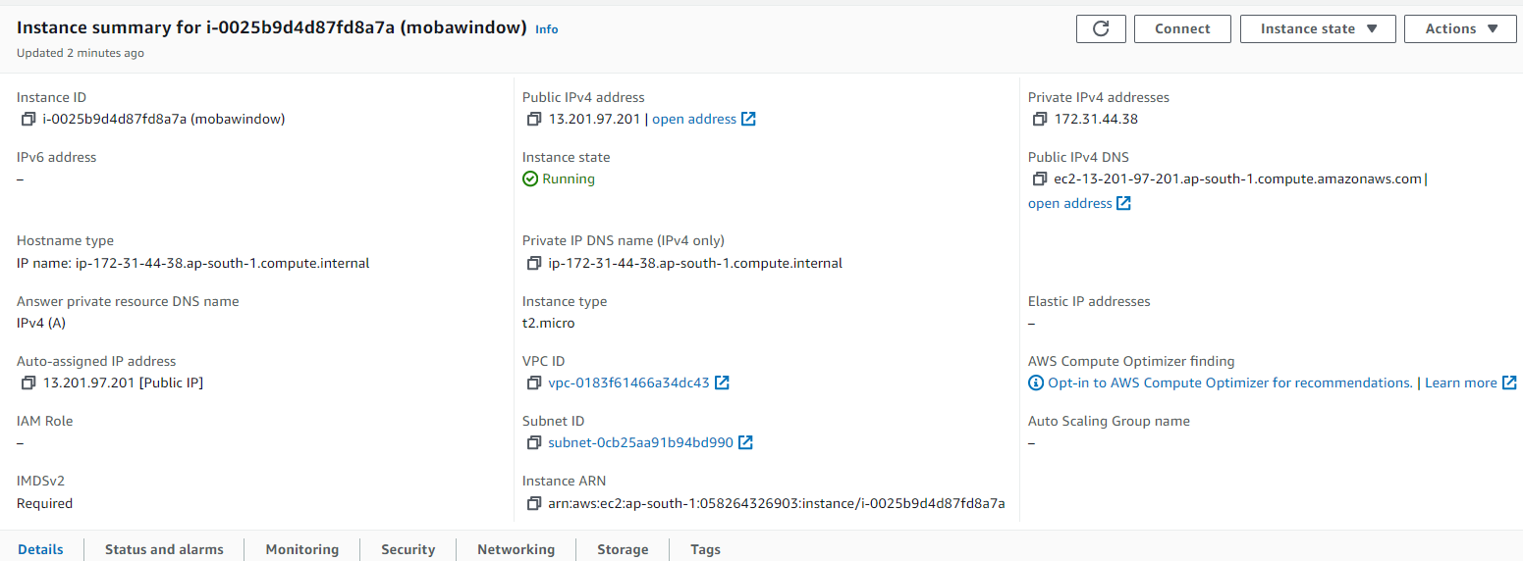

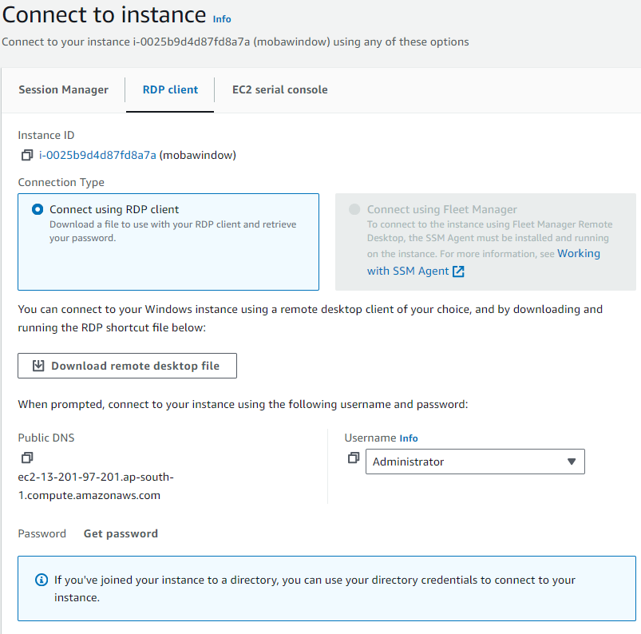

**Now we need to decrypt the password by uploading the key pair file created.**

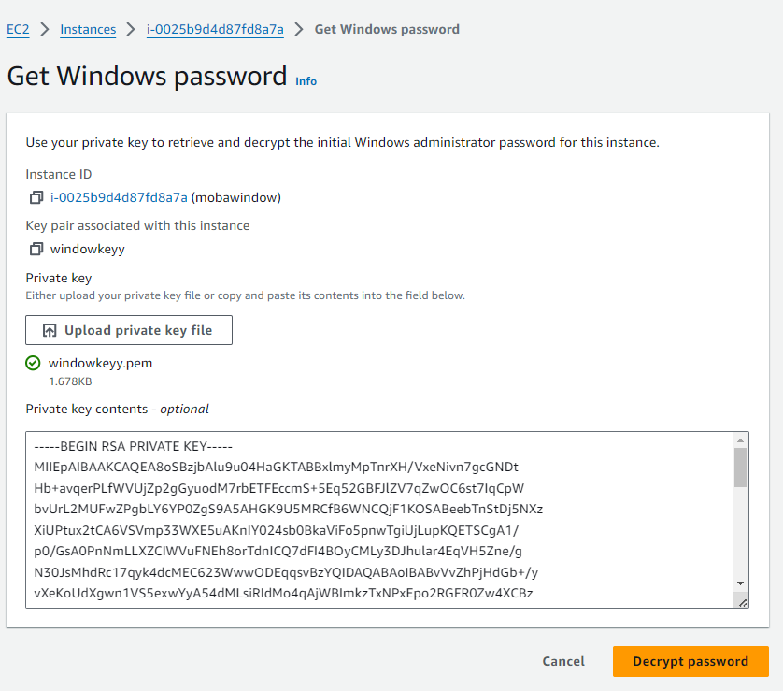

**The password is decrypted**

**And now after entering the password the Virtual environment is created .**